Half adder using NAND gate

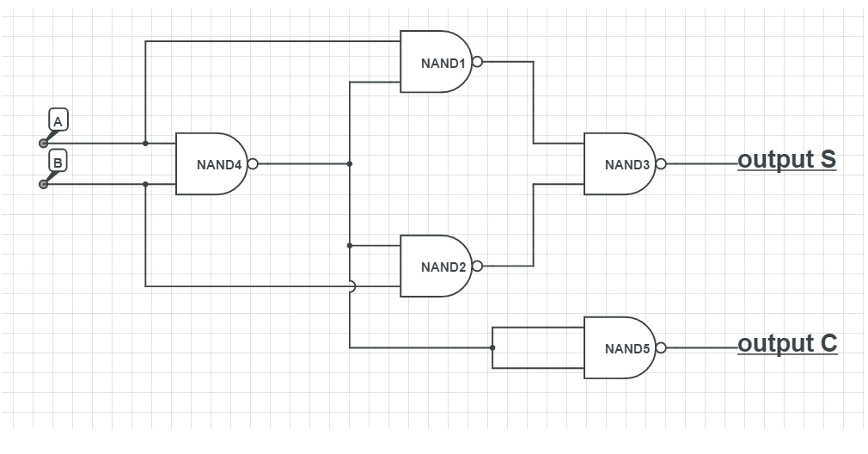

Half adder using NOR gate

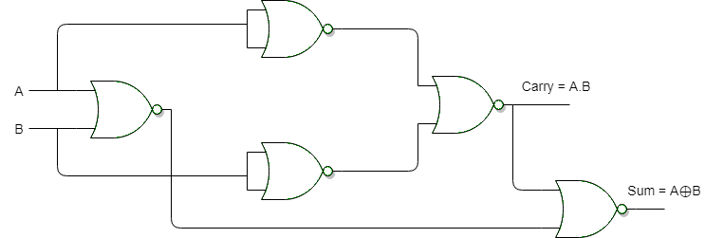

Full adder using 3input OR gate

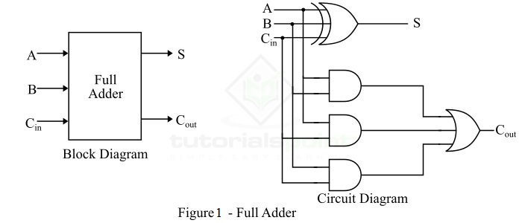

Full adder using 3input NAND gate